Project Number: 2

Project Name : Assembly of a Juicer

Project Complexity: Low

Project Overview:

Class project for ME10 (materials and manufacturing) to introduce us to solidworks, particularly the assembly aspect of things. The assignment required 3D assembly of a hand operated juicing machine from a set of modelled components that was provided along with a specification.

Tools used included the likes of the sketch tool, extrude/cut tools and chamfer/fillet tools. The project also built on ability to understand and use engineering drawings.

Project Images:

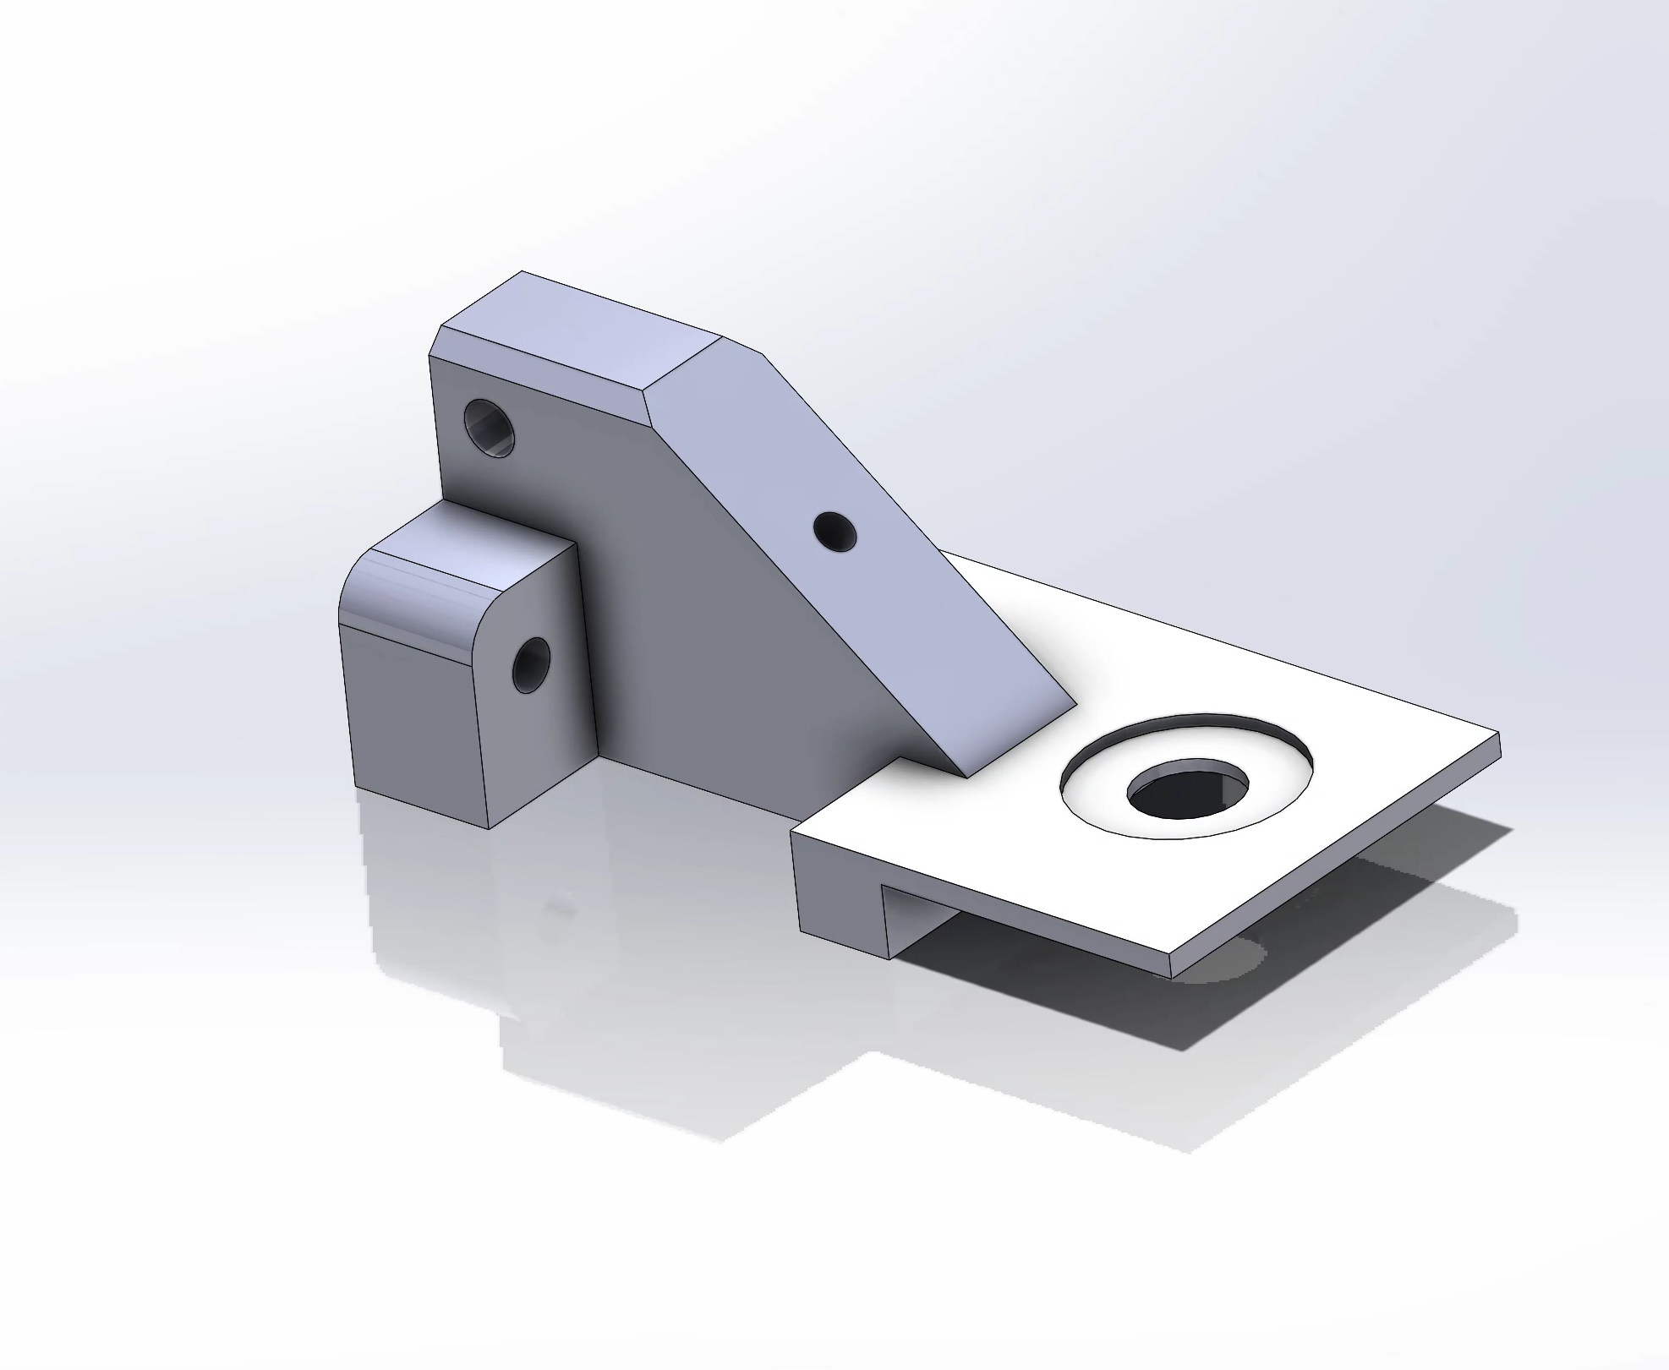 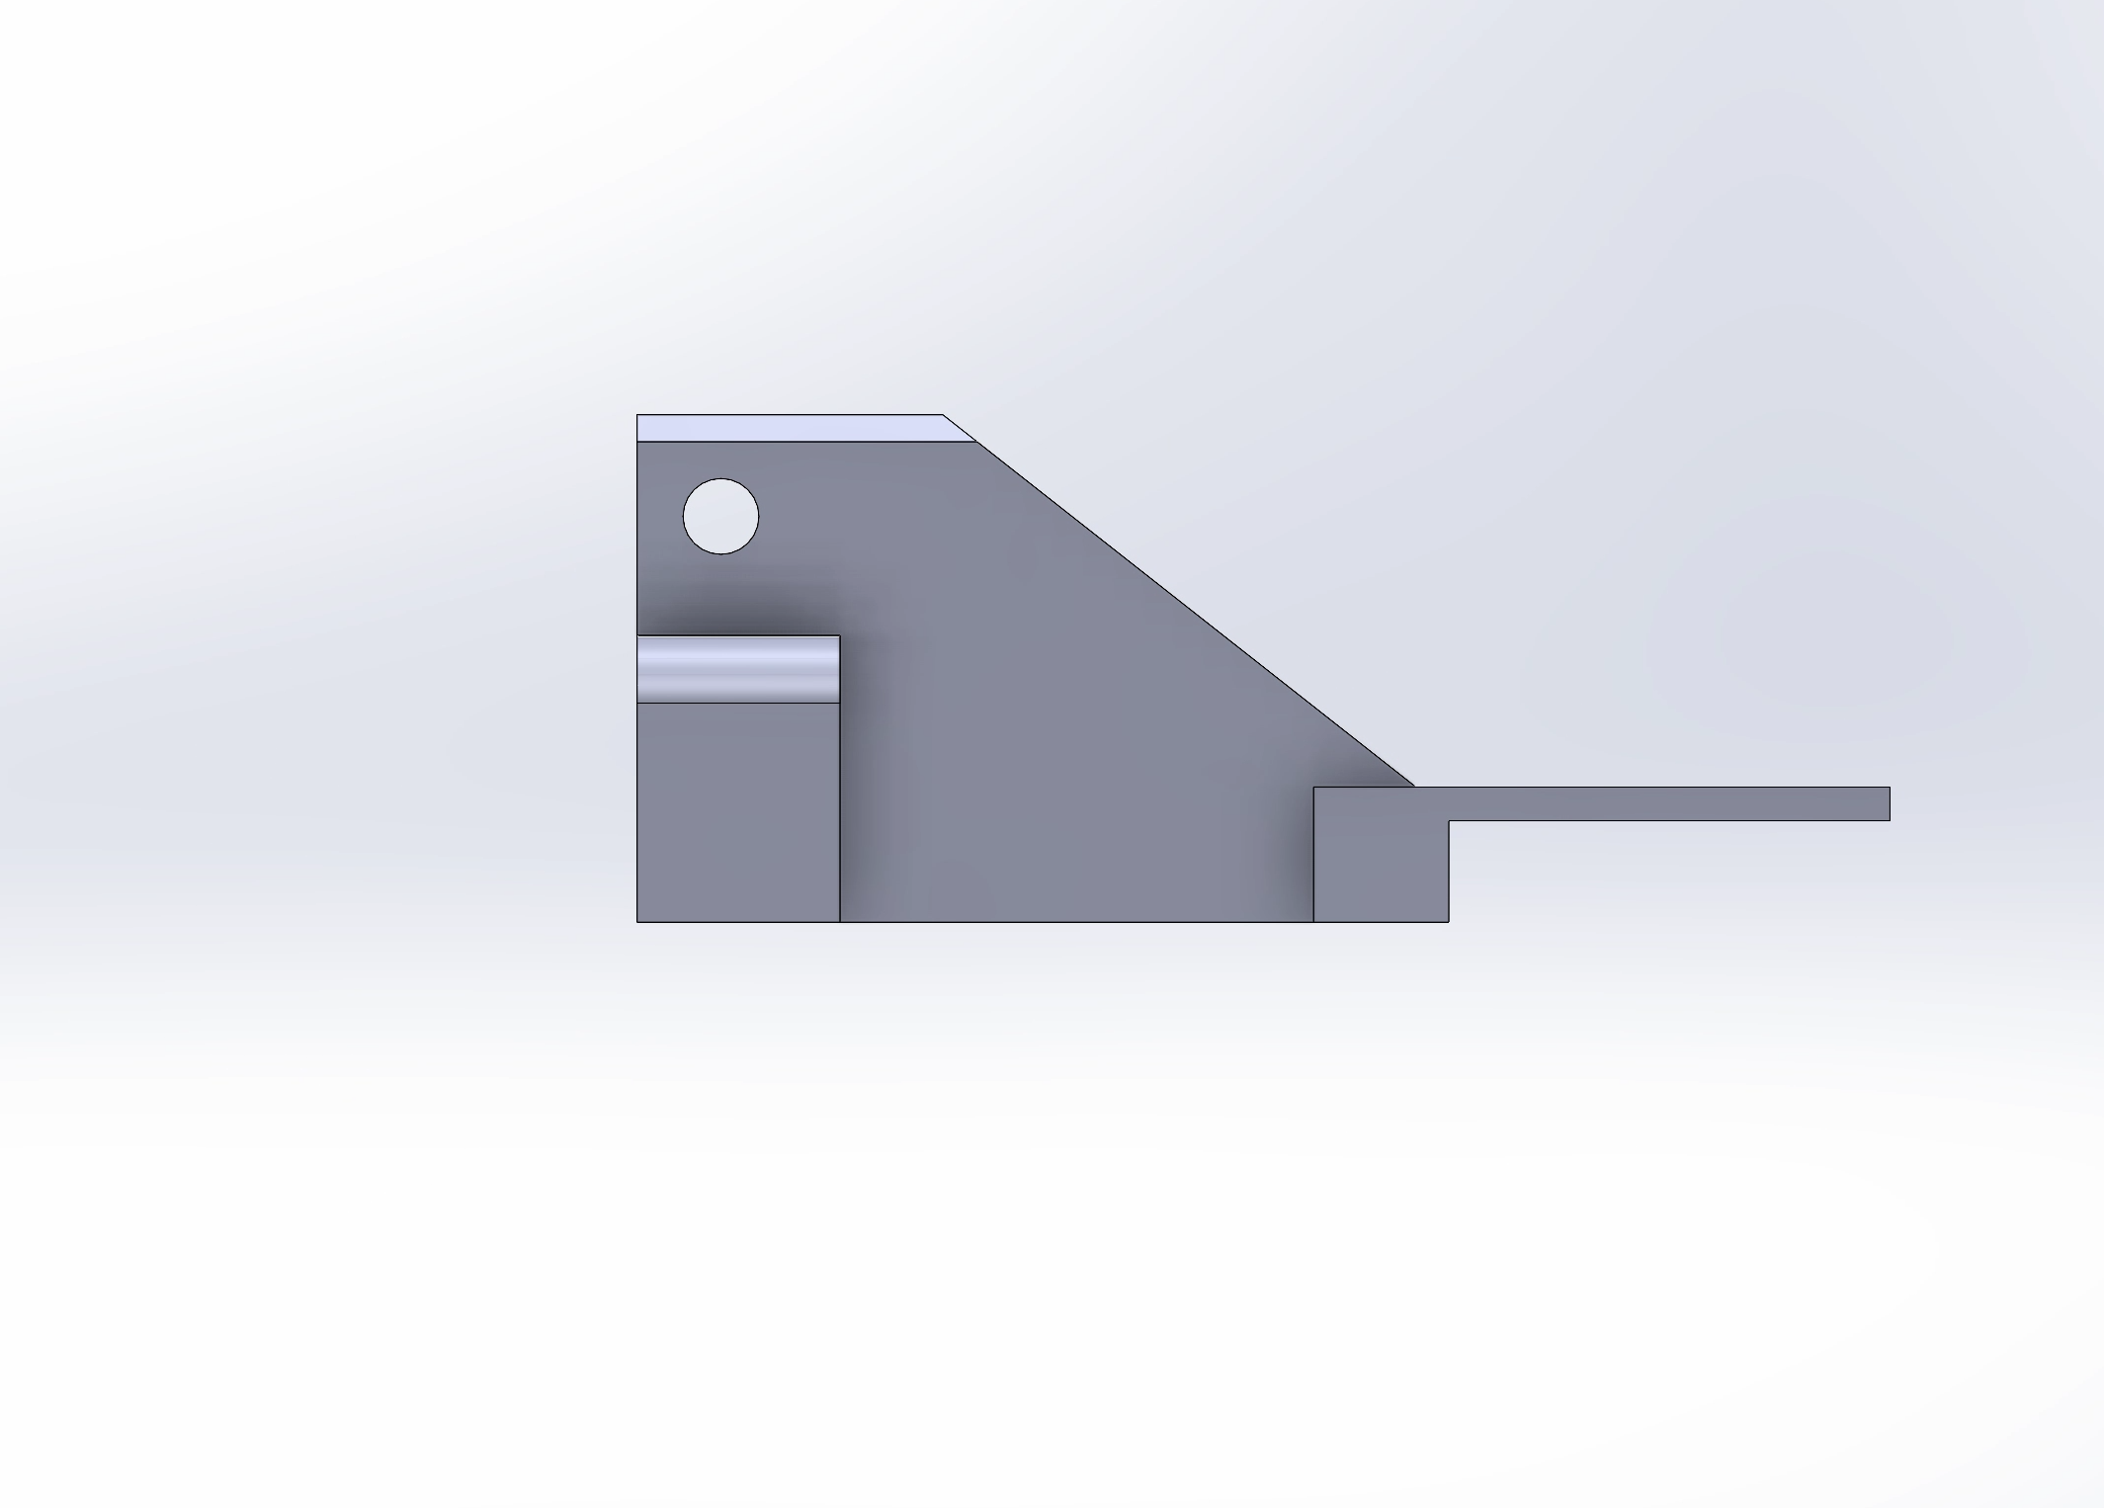

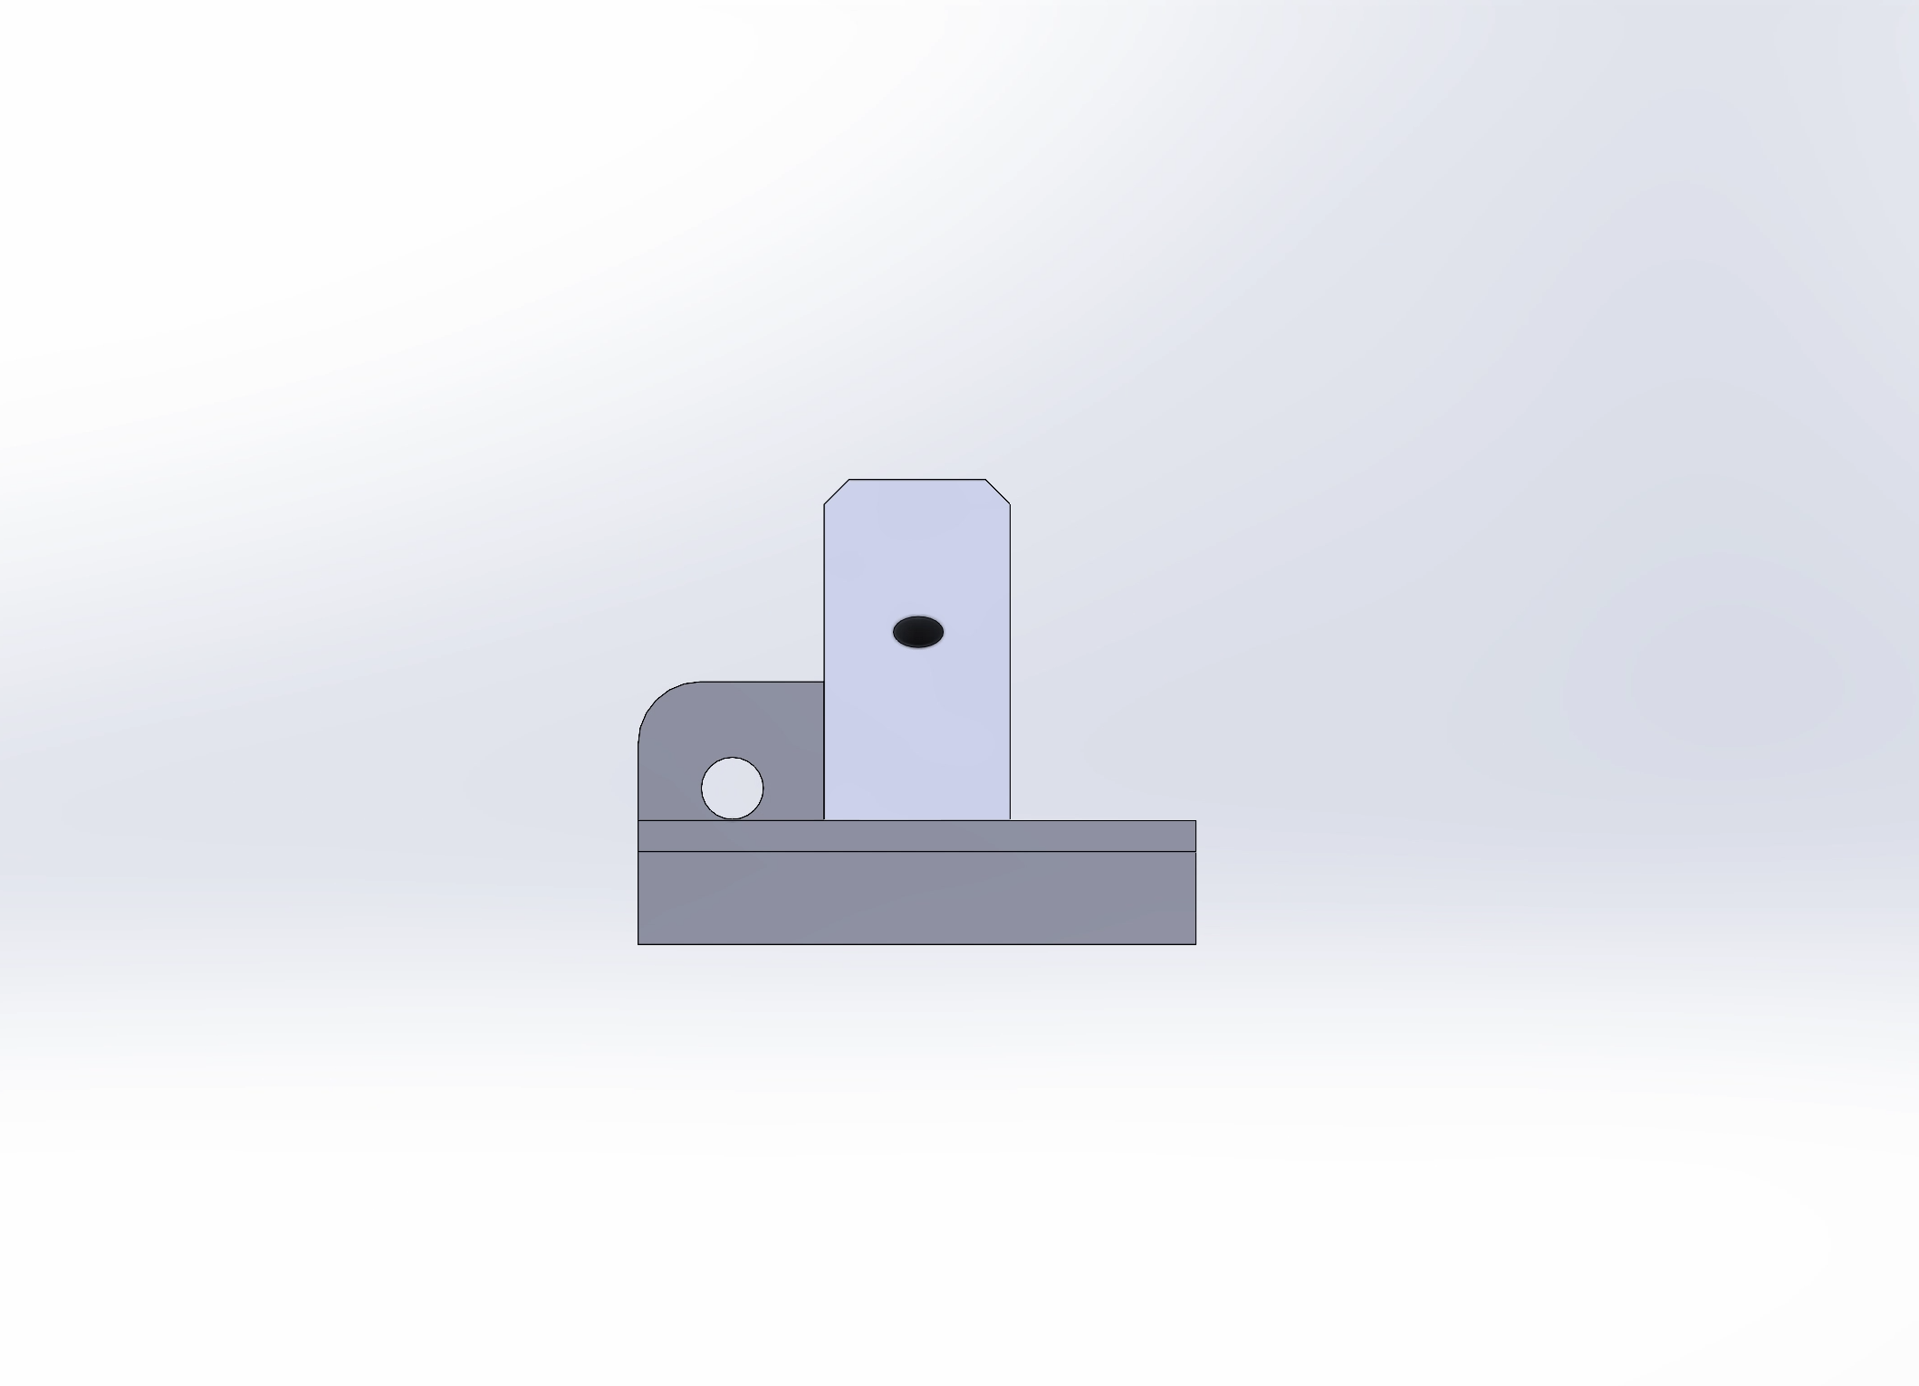

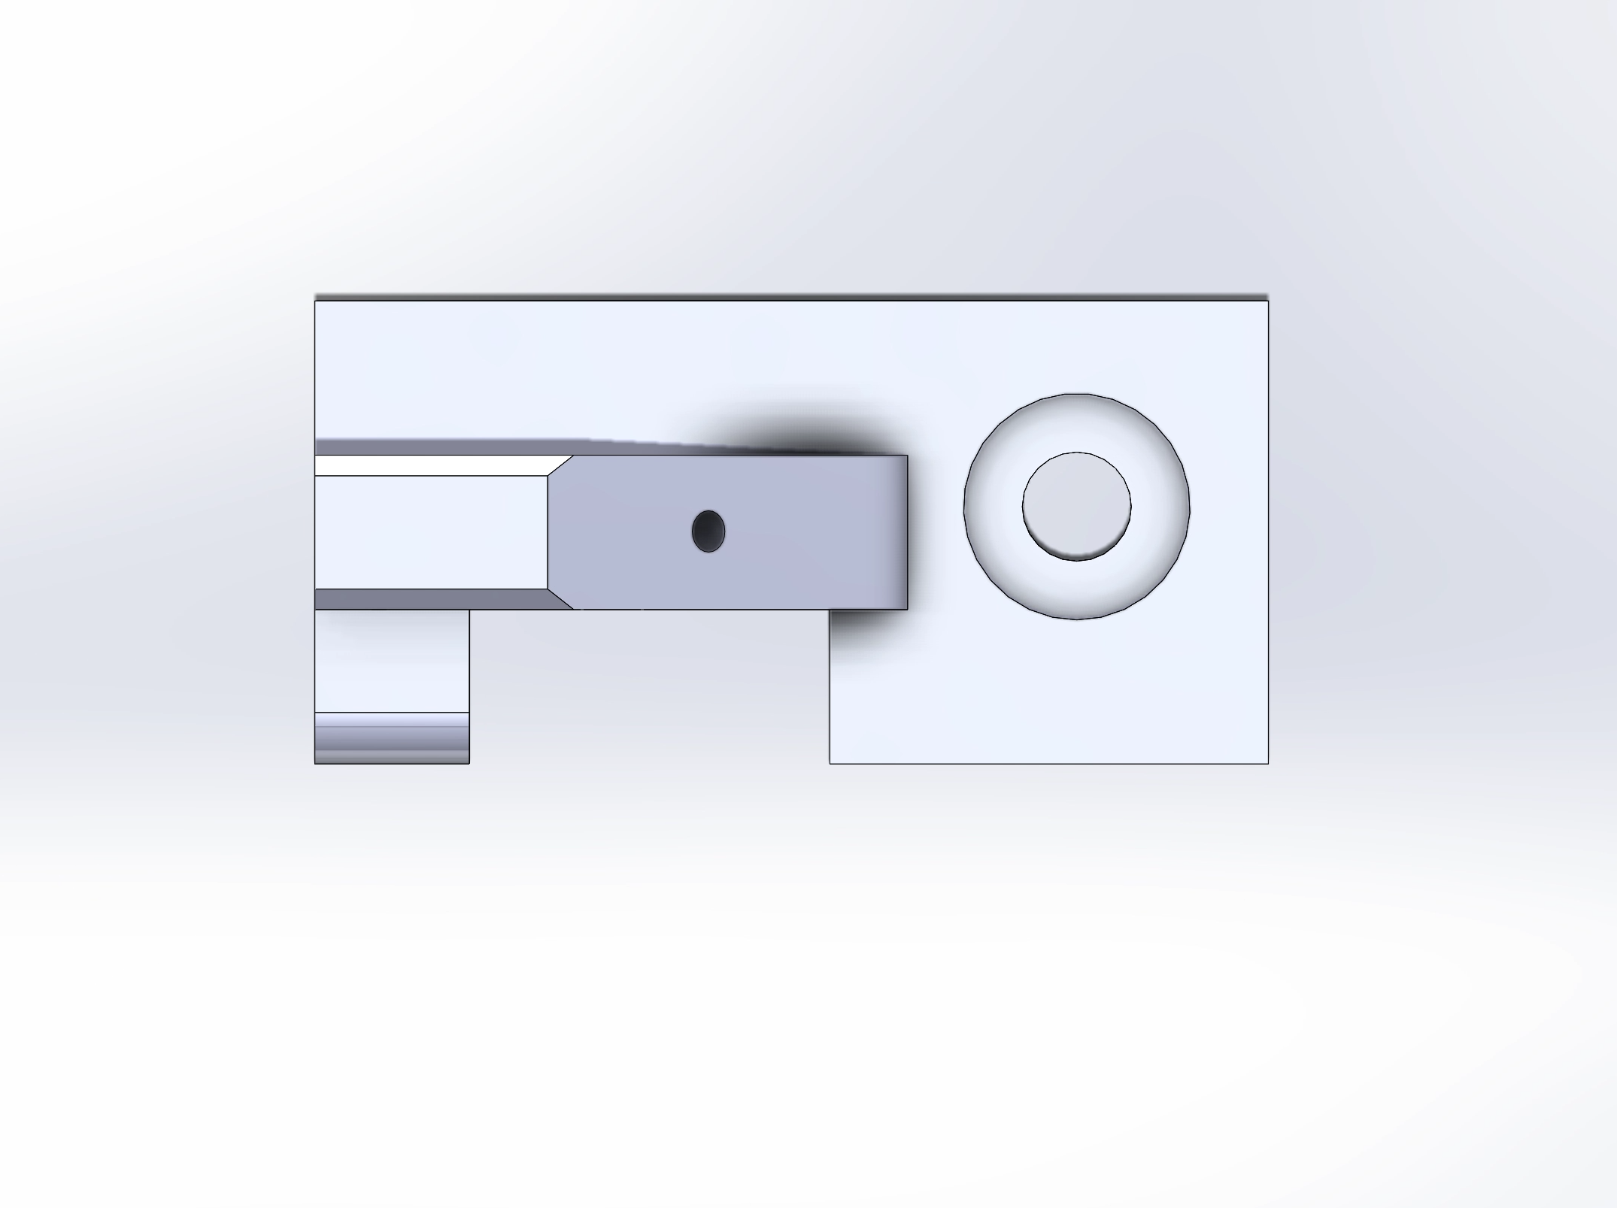

Project Outcome:

The project was a success, ability to effectively use basic features of solidworks was established. All requirements of the assignments original specification were met. In addition thanks to finish the project early given its relatively limited scope I was able to explore solidworks further, particularly the rendering and view side of things.